MATHS - 2003 (Set II— Outside Delhi)
Except for the following questions, all the remaining questions have been asked in Set I.
Q. 1. Solve :
Ans. 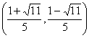
Q. 3. Find the values of a and b for which the following system of linear equations has infinite number of solutions :
Ans. (A = 3); (b = 2)
Q. 4. Express the following as a rational expression in lowest form:
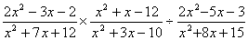
Ans. (1)
Q 7. It is known that a box of 600 electric bulbs contains 12 defective bulbs. One bulb is taken out at random from this box. What is the probability that it is a non-defective bulb?
Ans. (0.98)
Q. 8. A(7, 0), B(0, -24) and O(0, 0) are the vertices of a triangle. Calculate the length of the hypotenuse of the right angled
Ans. (25)
Q. 13. A right with sides 3 cm and 4 cm is revolved around its hypotenuse. Find the volume of the double cone thus generated.
Ans. (30.17 cm 2 )
Q. 16. Find the five numbers in A.P. whose sum is 25 and the sum of whose square is 135.
Ans. (3, 4, 5, 6, 7, or 7, 6, 5, 4, 3)
Q. 17. The given pie chart represents the number of valid votes obtained by 4 students who contested for school leadership. The total number of valid votes polled was 720 Read the pie chart and answer the following questions:
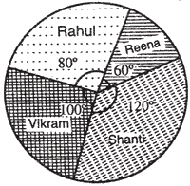
(1) Who has won the election?
(2) What is the mini-mum number of votes obtained by any candidate?
(3) By how many votes did the winner defeat the nearest contestent?
(4) What % of the valid votes polled was obtained by the winning candidate?
Ans. (Shanti, (2) 120 by Reena (3) 40 (4) 33 %
Q. 18. Without using trigonometric tables, evaluate the following:
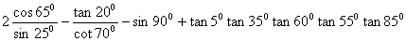
Ans.

